Transcript Information Transcripts should be requested from Mrs. Gibson, Counseling Secretary, by email.

Urbandale High School
Senior Bulletin September 18, 2020
Also available at http://www.uhsguidance.com/senior-bulletinresources.html

Include in your request email
- Your first and last name
- Your graduation year
- If you need a
  - certified copy sent to a college to complete an application, provide name of college / university and their admissions office email.
  - copy for yourself for reference or to include in an electronic scholarship application, your transcript will be emailed to your school email.

Email Mrs. Gibson if you have questions about the process or what type of transcript you need.

Allow 2 days for transcript requests to be processed. Please check due dates CAREFULLY, and plan ahead!

College and Scholarship Application Documents to be completed by a school counselor must be submitted to your counselor at least five (5)* school days before deadline. The Counseling Office needs at least 5 days to make sure that all materials are completed and signed, a transcript is printed, and item is prepared by the due date. Please check due dates CAREFULLY, and plan ahead!
*Any college or scholarship application document, due less than five (5) school days from the day that you submit it to the Counseling Office and request a transcript, is not guaranteed to be prepared on time.
Letters of Recommendation are not entitlements; they are earned. They should be politely requested, in person, at least two weeks before the deadline, from someone who knows you. It takes time to craft a well-written recommendation that reflects the uniqueness of the student.
Please provide, in writing, to the person you are are asking to write a recommendation for you
- to whom it is written
- for what purpose it is being written
- does the reader of the recommendation provide any instructions? If so, include them
- provide the deadline
- provide an envelope with the reader’s name/address, if the letter is to be mailed separately or included with an application being mailed, or
- provide the email address of the reader if the letter is to emailed
- if the writer is to comment on your participation, honors, awards, etc., provide a list of your participation, honors, awards
Always say “Thank you” to the person who provides a recommendation letter for you.
Resources A variety of test preparation, financial aid, and post-secondary materials are available for check out. Please see Mrs. Gibson in the Counseling Office.
ACT Testing Register for the ACT online at www.actstudent.org. When registering you will need the Urbandale High School Code: 161220. You may choose to take the test at any available test site. There are no test dates scheduled at UHS at this time. Check here for 2020-2021 test dates or see below.

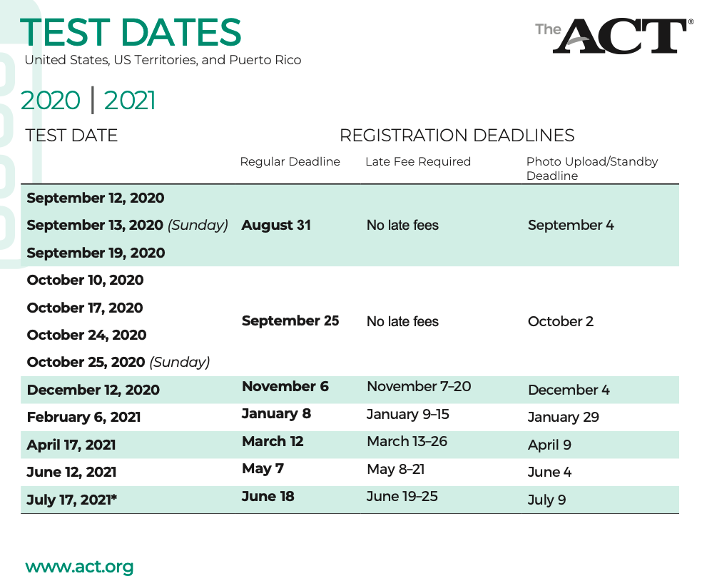
Standby Testing If you miss the registration deadline for a test date, you can try to test standby. Instructions for standby testing are available online at actstudent.org. If you are already registered for a previous or future test date, try to make a Test Date Change instead. Standby testing may be available at test sites on a first-come-first-served basis for each test date.
College Visits
Scholarships
October Deadlines

AES Engineers is offering $500 scholarships to deserving students. To be eligible the student must answer
an essay question with 500-1000 words. Info at https://aesengineers.com/scholarships.php. Entry deadline is October 5, 2020.

The Heisman High School Scholarship program recognizes male and female community-minded scholar-athletes at the state and national level with 100 scholarship. Go to https://heismanscholarship.com/ for more information and application. Deadline is October 20, 20120.
The Horatio Alger Association Scholarship Program provides assistance to students who will graduate in spring of 2021, have financial need and have exhibited integrity and perseverance in overcoming personal adversity. Submit an application at https://scholars.horatioalger.org/ by October 25, 2020.
The Jack Kent Cooke Foundation College Scholarship Program is available to high-achieving high school seniors with financial need. This highly competitive scholarship includes up to $40,000 per year to attend a four-year accredited undergraduate school. For more information and to apply go to http://www.jkcf.org/scholarship-programs/college-scholarship/ by 11:59 p.m. CST, October 30, 2020.

Iowa Student Loan Save Now, Save Later: College Savings Plan Parent Giveaway - Thirty $1,000 deposits into College Savings Iowa accounts will be awarded to parents and guardians of Iowa students in grades 6-12. Visit the new Parent Handbook guide for important college financing information and enter contact information to register - http://www.iowastudentloan.org/SaveNow. Registration open until October 30, 2020.

The Coca-Cola Scholars Foundation awards $3 million a year in scholarships to deserving students. Apply online at https://www.coca-colascholarsfoundation.org/apply/. Application deadline is October 31, 2020.
The VFW (Veterans of Foreign Wars) sponsors the Voice of Democracy Patriotic Audio Essay Competition, with a grand prize of $30,000. The theme this year is “Is this the Country the Founders Envisioned?”. More information is available athttps://www.vfw.org/community/youth-and-education/youth-scholarships. Deadline is 11:59 p.m., October 31, 2020.
November Deadlines

The Elks National Foundation offers the 2021 Most Valuable Student Scholarship to any high school senior who is a US citizen, based on scholarship, leadership and financial need. Visit https://www.elks.org/scholars/ for information. Deadline is November 15, 2020.
December Deadlines

The Equitable Foundation provides the Equitable Excellence Scholarship to young people throughout the nation. Learn more and apply at https://equitable.com/foundation/equitable-excellence-scholarship?utm_source=usaxacom&utm_campaign=brandredirect&utm_medium=referral. Applications accepted until 10,000 applications are submitted or 11:59 pm, December 15, 2020, whichever comes first.
The Foundation for Individual Rights in Education (FIRE) offers scholarships through their “Free Speech Essay Contest.” High school juniors and seniors are eligible to participate. Awards range from $1,000 to $10,000. For specific instructions and online application go to www.thefire.org/contest. Entry deadline is 11:59 pm, December 31, 2020.
The Navy ROTC 2021 Scholarship application is open. It provides tuition, money for books and other fees, tax-free spending money of $250-$400 per month, 100% employment upon graduation, and unlimited travel opportunities
Go to: http://www.nrotc.navy.mil/ . Application submission deadline is midnight (CST) December 31, 2020.

January Deadlines

The Air force ROTC High School Scholarship Program offers scholarships to be used at any of the 1,200 colleges with Air Force ROTC programs. For more information, go to https://www.afrotc.com/scholarships .The deadline to apply is January 14, 2021.

College Covered by Discover Student Loan sponsors the 2020 Discover Student Loans Scholarship Sweepstakes. Throughout the year, 12 eligible students or parents will be randomly selected to win a $5,000 Discover Student Loans Scholarship Award to help cover college expenses. Go to https://scholarship.collegecovered.com/ for more information. Enter by 11:59 p.m., January 31, 2021.
The University of Iowa Department of Physics and Astronomy awards the Strayer-Rairden Scholarship in Physics, a $1,000 grant, renewable for up to three (3) successive years, to an entering freshman from the state of Iowa. This person is selected by the Department as the state’s best-qualified applicant who has declared physics or astronomy as their major. This scholarship is awarded on the basis of academic merit, not financial need. Please go to http://www.physics.uiowa.edu/undergraduate-program/undergraduate-scholarships-and-awards/strayer-rairden-scholarship-physics to view guidelines and obtain a copy of the application form. Application deadline is January 31, 2021.
February Deadlines

The Elks National Foundation offers Legacy Awards to children and grandchildren of Elks members. Legacy Awards applications are available online only at https://www.elks.org/scholars/scholarships/legacy.cfm and must be submitted by February 5, 2021, by11:59 a.m. Central Time.
The Hy-Vee Foundation Scholarship Program awards 80 - $1,000 scholarships to students seeking a four-year degree at any baccalaureate degree-granting college in the United States. More information at http://www.hy-vee.com/. Applications must be postmarked by February 10, 2020.

March Deadlines

Guardian Scholars Program - providing scholarships for students who have spent time in Foster Care in Iowa, or lived without the support of parents, between the ages of 14-18. Up to $8,000 year to help fund education at an Iowa college or university. Info at http://www.guardianscholarsfoundation.com/. Applications due March 1.

A-1 Auto Transport is offering 3 scholarships with awards of $1,000, $500 and $250. To apply, applicants must write an essay/article (at least 1000 words and not posted elsewhere on the internet) about a topic related to the A-1 Auto Transport site. Go to https://www.a1autotransport.com/a-1-auto-transport-scholarship/ for details. Email your essay/article to mailto:scholarships@a1autotransport.com along with your full name, contact information and school you will be attending. Application deadline is March 10, 2021.

May Deadlines

The American College Foundation Visionary Scholarship Program awards multiple scholarships ranging from $1,000 to $5,000. Freshman, sophomore, junior and senior students are eligible. Apply at http://www.americancollegefoundation.org/ by May 1, 2021.

Various Deadlines

Iowa State University: Go to www.financialaid.iastate.edu for information on scholarships at Iowa State University. Site will reopen on October 1, 2020.
The University of Iowa: Go to https://admissions.uiowa.edu/finances/scholarships-first-year-students to review all scholarships available to full-time first-year students entering the University directly from high school.
University of Northern Iowa: Go to https://uni.edu/finaid/scholarship for information regarding scholarships available to UNI students.
The OppU Achievers Scholarship provides $2,500 to high-achieving students for tuition costs. To apply, submit a short response at http://opploans.com/scholarship. To be eligible, a student must be enrolled full-time in high school or at least par-time in college or trade school, and have a GPA of at least 3.0/4.0. The scholarship is awarded four times a year, with submission deadlines on September 30, December 31, March 31 and June 30.
Bright Scholars of Iowa Award Funded by the Bright Foundation, this award is a need and merit based grant designed to help ensure a selected number of outstanding Iowa high school seniors have the financial means to complete a two-year or four-year college education without debt. The amount of the scholarship is equal to the cost of attendance, less other gift aid (including Pell Grants, institutional grants and scholarships, and private scholarships). This award is renewable for up to three additional years, providing the student maintains a 2.50 cumulative GPA and full-time enrollment. Bright Scholars of Iowa Awards are granted by Iowa State University, University of Iowa, University of Northern Iowa, Southwest Community College, and Indian Hills Community College. For more information visithttp://www.brightscholarsofiowa.org/. Deadlines vary by college.

College Board Opportunity Scholarships A program that guides you through the college application process. No essay, application, or minimum GPA required. Students are rewarded for effort and initiative by completing key steps along the path to college for a chance to earn scholarships The more effort you put in, the more opportunities you have to earn a scholarship. Complete all six steps, and you’re eligible to earn $40,000. Scholarships will be awarded through monthly drawings to students who complete each action. Go to https://opportunity.collegeboard.org/.

Mount Mercy University Catherine McAuley Scholarship (Cedar Rapids. IA) Eligible students are Iowa residents who graduated from an Iowa high school, and whose family income is $45,000 or less annually. Students are expected to reside on campus all four years, participate in the College Success Program during their first year, and file FAFSA. More info at http://mtmercy.edu/free-tuition.

Websites
Search for scholarships - these sites are updated regularly:

www.fastweb.com
www.finaid.org
https://www.cappex.com/scholarships/
www.studentscholarships.org
www.scholarshipguidance.com
www.scholarships.com

Help in completing the FAFSA:
www.fafsa.ed.gov
https://studentaid.ed.gov/sa/fafsa
College Information:
MyMajors.com is a site with information to assist you in selecting a college major. www.MyMajors.com
· Recommends 5 majors appropriate to a student’s background from among 100 of the most commonly found majors (40 more than previously)
· Improves the logic used to make recommendations, including the asking of questions about a student’s extracurricular activities and high school electives
· Contains more helpful content about majors and college planning
· Offers links to colleges offering the various majors

