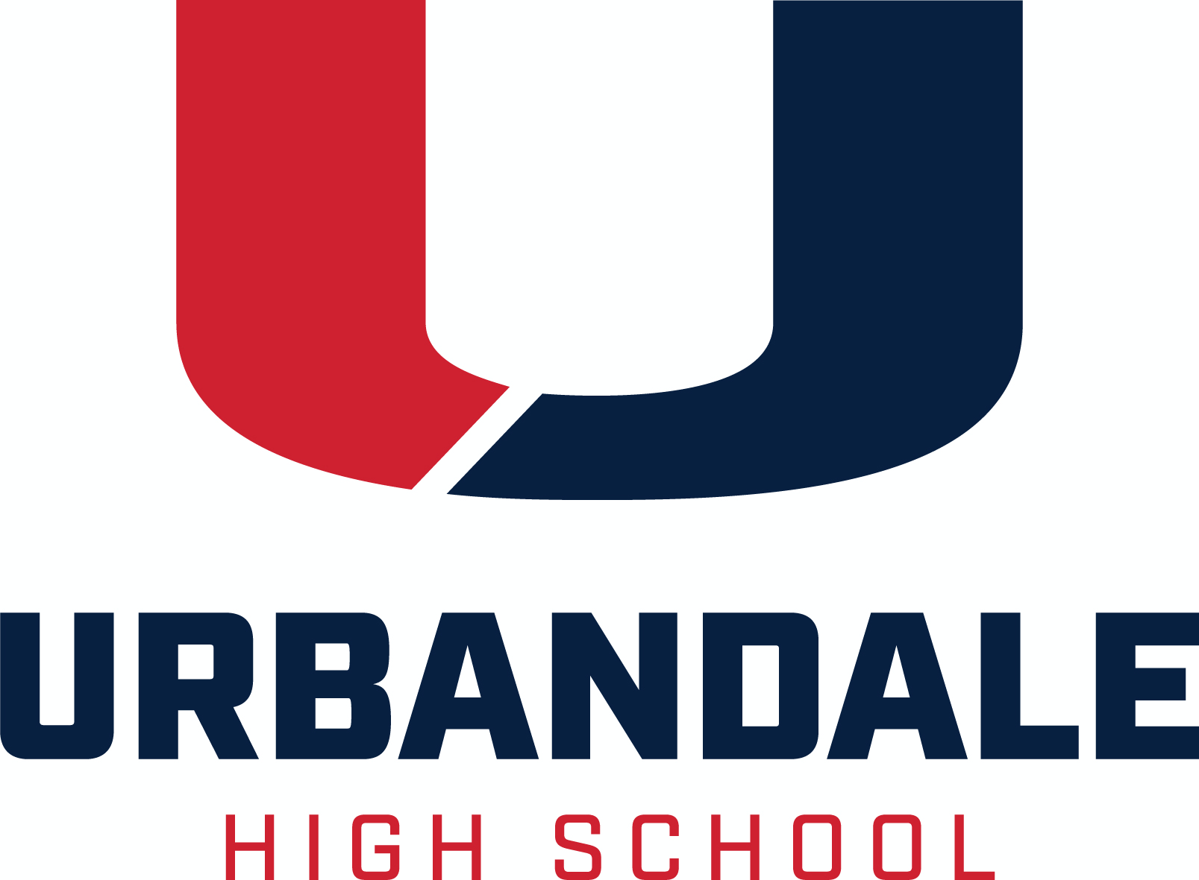
Senior Bulletin May 4, 2022

SCROLL DOWN FOR THE SCHOLARSHIP LIST

College Visits These are small, informal meetings in the UHS counseling office. Admissions counselors from colleges and universities come to the high school to meet with interested students, presenting overviews of their schools and providing students an opportunity to ask questions and talk one-on-one with an admissions counselor.
DMACC Wednesday, May 11 2:00-8:00 p.m. UHS Room 111
2:00-5:30 p.m. Come get help from a DMACC Rep with:
          - Applying for Admissions
          - Completing Orientation
          - DMACC Scholarships/Financial Aid
6:00-8:00 p.m. DMACC Admissions Presentation
Transcript Information Transcripts should be requested in the Counseling Office by completing the gold Transcript Request at the front desk, or by email to Mrs. Gibson, gibsonj@urbandaleschools.com
Include in your request email
- Your first and last name
- Your graduation year
- Name and address of school or college or other destination for the transcript
- If you need an unofficial copy emailed to you for your own reference, please indicate that in your email.

Email Mrs. Gibson if you have questions about the process or what type of transcript you need.

Allow 2 days for transcript requests to be processed. Please check due dates CAREFULLY, and plan ahead!

College and Scholarship Application Documents to be completed by a school counselor must be submitted to your counselor at least five (5)* school days before deadline. The Counseling Office needs at least 5 days to make sure that all materials are completed and signed and ready by the due date. Please check due dates CAREFULLY, and plan ahead!
*Any college or scholarship application document, due less than five (5) school days from the day that you submit it to the Counseling Office and request a transcript, is not guaranteed to be prepared on time.
Letters of Recommendation are not entitlements; they are earned. They should be politely requested, in person, at least two weeks before the deadline, from someone who knows you. It takes time to craft a well-written recommendation that reflects the uniqueness of the student. Always say “Thank you” to the person who provides a recommendation letter for you.
Please provide, in writing, to the person you are asking to write a recommendation for you
- to whom it is written
- for what purpose it is being written
- does the reader of the recommendation provide any instructions? If so, include them
- provide the deadline
- provide an envelope with the reader’s name/address, if the letter is to be mailed separately or included with an application being mailed, or

- provide the email address of the reader if the letter is to emailed
- if the writer is to comment on your participation, honors, awards, etc., provide a list of your activities, honors, awards
Resources A variety of test preparation, financial aid, and post-secondary materials are available for check out. Please see Mrs. Gibson in the Counseling Office.
Help with Completing the FAFSA - Get free assistance completing the FAFSA (Free Application for Federal Student Aid) at an ICAN (Iowa College Access Network) location near you. To schedule an appointment, visit https://www.icansucceed.org/ or call (877) 272-4692.
ACT Testing Register for the ACT online at http://act.org/. The Urbandale High School Code is 161220. You may choose to take the test at any available test site. See test dates below. This year, UHS is tentatively scheduled to offer the ACT on all but the February 2022 date.
Standby Testing If you miss the registration deadline for a test date, you can try to test standby. Instructions for standby testing are available online at actstudent.org. If you are already registered for a previous or future test date, try to make a Test Date Change instead. Standby testing may be available at test sites on a first-come-first-served basis for each test date.

SCHOLARSHIPS
Various Deadlines

Iowa College Aid compiles information on all State of Iowa grants and scholarships and provides lots of financial aid information for students and parents. Go to https://www.iowacollegeaid.gov/.
Iowa State University: Go to www.financialaid.iastate.edu for information on scholarships at Iowa State University.
The University of Iowa: Go to https://admissions.uiowa.edu/finances/scholarships-first-year-students to review all scholarships available to full-time first-year students entering the University directly from high school.
University of Northern Iowa: Go to https://uni.edu/finaid/scholarship for information regarding scholarships available to UNI students.
CollegeBoard offers the BigFuture Scholarship Search. For more information on various scholarship offerings, go to https://bigfuture.collegeboard.org/scholarship-search - !personalinformation.

The Naval Reserve Officer Training Corps (NROTC) offers a $180,000 scholarship that pays for tuition and a monthly stipend. Following participation in the program, you will graduate with a bachelors degree and a commission as a Marine Corps officer. Minimum qualifications: SAT-1000, ACT-22, ASVAB: 74, between the ages of 17-23, U.S. citizen and physically qualified. To apply, contact Capt. Adam Meyers, 817-600-0841 or adam.meyers@marines.usmc.mil as soon as possible.

ECSEL (Electrical, Computer and Software Engineers as Leaders) at DMACC – Interested in engineering? Start at DMACC and transfer to Iowa State University. $5,000 ad $1,000 renewable scholarships are available for students. For more information and the scholarship application, visit http://dmacc.edu/ecsel.

The OppU Achievers Scholarship provides $2,500 to high-achieving students for tuition costs. To apply, submit a short response at http://opploans.com/scholarship. To be eligible, a student must be enrolled full-time in high school or at least part-time in college or trade school, and have a GPA of at least 3.0/4.0. The scholarship is awarded four times a year, with submission deadlines on September 30, December 31, March 31 and June 30.
Bright Scholars of Iowa Award Funded by the Bright Foundation, this award is a need- and merit- based grant designed to help ensure a selected number of outstanding Iowa high school seniors have the financial means to complete a two-year or four-year college education without debt. The amount of the scholarship is equal to the cost of attendance, less other gift aid (including Pell Grants, institutional grants and scholarships, and private scholarships). This award is renewable for up to three additional years, providing the student maintains a 2.50 cumulative GPA and full-time enrollment. Bright Scholars of Iowa Awards are granted by Iowa State University, University of Iowa, University of Northern Iowa, Southwest Community College, and Indian Hills Community College. For more information visit http://www.brightscholarsofiowa.org/. Deadlines vary by college.

College Board Opportunity Scholarships A program that guides you through the college application process. No essay, application, or minimum GPA required. Students are rewarded for effort and initiative by completing key steps along the path to college for a chance to earn scholarships The more effort you put in, the more opportunities you have to earn a scholarship. Complete all six steps, and you’re eligible to earn $40,000. Scholarships will be awarded through monthly drawings to students who complete each action. Go to https://opportunity.collegeboard.org/.

Mount Mercy University Catherine McAuley Scholarship (Cedar Rapids. IA) Eligible students are Iowa residents who graduated from an Iowa high school, and whose family income is $45,000 or less annually. Students are expected to reside on campus all four years, participate in the College Success Program during their first year, and file FAFSA. More info at http://mtmercy.edu/free-tuition.

May Deadlines

The 2022 Robert D Blue Scholarship is open to any Iowa student who plans to attend an Iowa college or university. Applicants are expected to demonstrate literary and scholastic ability, exhibit qualities of truth, courage and fellowship, and display moral force of character. Application includes a 500-word essay. Information and application are available at www.rdblue.org . Deadline for submission is Tuesday, May 10, 2022.

Applications are open for the Mary E. Woods Scholarship and the Larry W. Carter Scholarships for African-American students seeking higher education. For more information, visit https://communityfoundationmarywood.wordpress.com/application/ and https://communityfoundationofgreaterdesmoines.wordpress.com/about/. Students with questions may contact Katie Getting at the Community Foundation of Greater Des Moines at mailto:getting@desmoinesfoundation.org or 515-447-4208.Application deadline is May 15, 2022.

The DREAM Iowa Scholarship is open to students that come from an immigrant or refugee family (regardless of immigration status). Applicants must already be accepted to a college/university. The topic of the required essay is addressing the adversity that they have faced and how they plan to utilize their education to give back to the immigrant community. For more information and to apply go to https://docs.google.com/forms/d/e/1FAIpQLSeE6BTN5FUP4ypT-AhoPC1a01FwESpS0AjgLR_5yQ5rWVfNiQ/viewform. Application deadline is May 15, 2022.

The PB&J Scholarship is for students who have experienced personal challenges that may not have allowed them to perform well academically, but who still have the dive to succeed. With no GPA requirement, students are encouraged to apply as this scholarship is meant to be inclusive. Apply at bit.ly/pbjscholarship2022. Deadline is May 30, 2022.

June Deadlines

The Iowa PGA Foundation offers the Charlie Burkart Scholarship, $1,500 per year for four years at a college or university of their choice. Winners are selected on the basis of their interest and activity in golf, potential for future contributions to the game, leadership skills/community involvement, academic ability and financial need. Applications are available in the Scholarship Drawer in the counseling office. Application deadline is
June 18, 2022.

July Deadlines

Beta Sigma PSI-Iowa State offers two scholarships for men attending ISU in the fall of 2022: Apply at http://www.epsilon.betasigmapsi.org/scholarship.
- The Darryl Jahn Scholarship awards three $2,000 scholarships to Lutheran men. Due dates: February 5, April 2 and July 2, 2022.
- The Jake Vanderslice Scholarship awards one $1,000 scholarship. Due date is July 2, 2022.

The DMACC Foundation works with donors to create access to higher education through scholarships for students attending DMACC. Go to https://www.dmacc.edu/foundation/Pages/scholarships.aspx for more information. For spring semester 2023, apply May 1, 2022-July 15, 2022.

August Deadlines

Children’s Cancer Connection’s Empowering Scholarships Applicants must be directly affected by childhood cancer (including individuals who currently have or have had cancer before age 18 or a sibling of that individual, must live and be treated or diagnosed in the state of Iowa and plan to attend an accredited two-or four-year institution (trade school, college or university). For information and application, go to https://childrenscancerconnection.org/family-programs/empowering-scholarships.html. Applications for the Fall 2022 semester are due Monday, January 31, 2022. Applications for the Spring 2023 semester are due Wednesday, August 31, 2022.
Scholarship Websites
Search for scholarships - these sites are updated regularly:
https://iowacollegeaid.gov/
https://www.scholarships.com/
www.fastweb.com
https://www.cappex.com/scholarships/www.finaid.org
http://www.scholarshipguidance.com/
http://www.studentscholarships.org/

FAFSA Information: https://studentaid.gov/h/apply-for-aid/fafsa

