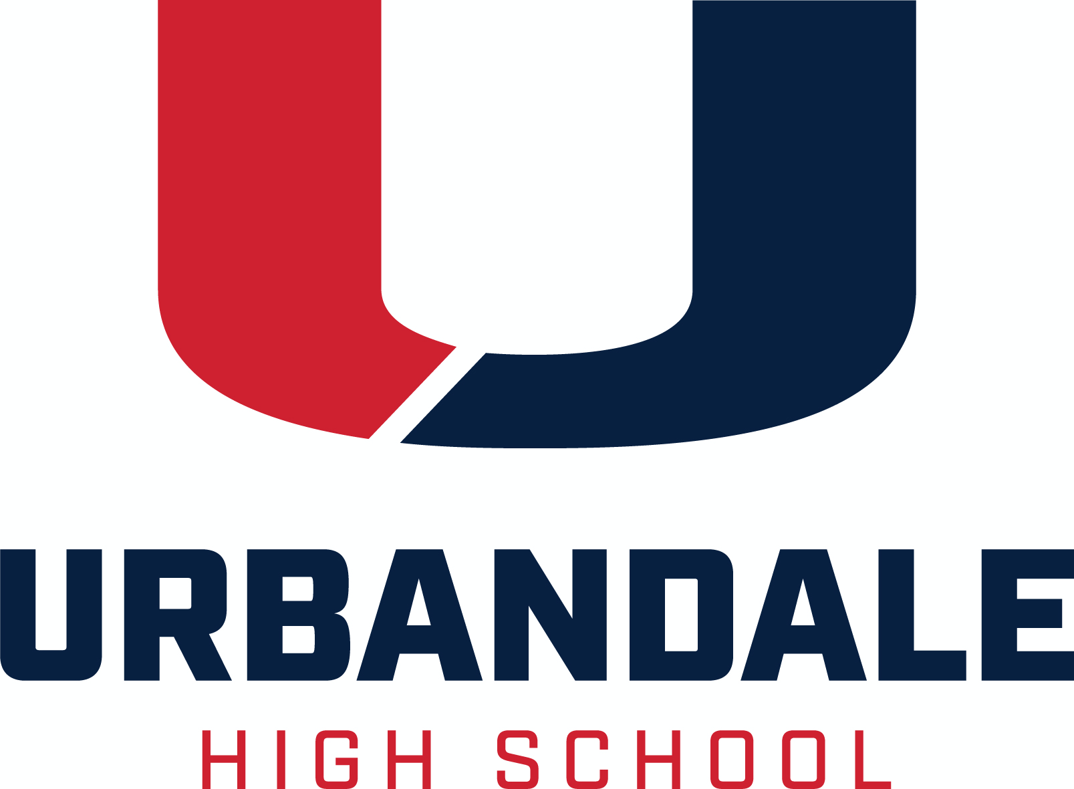
Senior Bulletin January 21, 2022

Transcript Information Transcripts should be requested in the Counseling Office by completing the gold Transcript Request at the front desk, or by email to Mrs. Gibson, gibsonj@urbandaleschools.com
Include in your request email
- Your first and last name
- Your graduation year
- Name and address of school or college or other destination for the transcript
- If you need an unofficial copy emailed to you for your own reference, please indicate that in your email.

Email Mrs. Gibson if you have questions about the process or what type of transcript you need.

Allow 2 days for transcript requests to be processed. Please check due dates CAREFULLY, and plan ahead!

College and Scholarship Application Documents to be completed by a school counselor must be submitted to your counselor at least five (5)* school days before deadline. The Counseling Office needs at least 5 days to make sure that all materials are completed and signed and ready by the due date. Please check due dates CAREFULLY, and plan ahead!
*Any college or scholarship application document, due less than five (5) school days from the day that you submit it to the Counseling Office and request a transcript, is not guaranteed to be prepared on time.
Letters of Recommendation are not entitlements; they are earned. They should be politely requested, in person, at least two weeks before the deadline, from someone who knows you. It takes time to craft a well-written recommendation that reflects the uniqueness of the student.
Please provide, in writing, to the person you are asking to write a recommendation for you
- to whom it is written
- for what purpose it is being written
- does the reader of the recommendation provide any instructions? If so, include them
- provide the deadline
- provide an envelope with the reader’s name/address, if the letter is to be mailed separately or included with an application being mailed, or
- provide the email address of the reader if the letter is to emailed
- if the writer is to comment on your participation, honors, awards, etc., provide a list of your participation, honors, awards
Always say “Thank you” to the person who provides a recommendation letter for you.
Resources A variety of test preparation, financial aid, and post-secondary materials are available for check out. Please see Mrs. Gibson in the Counseling Office.
Help with Completing the FAFSA - Get free assistance completing the FAFSA (Free Application for Federal Student Aid) at an ICAN (Iowa College Access Network) location near you. To schedule an appointment, visit https://www.icansucceed.org/ or call (877) 272-4692.

ACT Testing Register for the ACT online at http://act.org/. The Urbandale High School Code is 161220. You may choose to take the test at any available test site. See test dates below. This year, UHS is tentatively scheduled to offer the ACT on all but the February 2022 date.
Standby Testing If you miss the registration deadline for a test date, you can try to test standby. Instructions for standby testing are available online at actstudent.org. If you are already registered for a previous or future test date, try to make a Test Date Change instead. Standby testing may be available at test sites on a first-come-first-served basis for each test date.

College Visits
Northwest Missouri State University February 14 9:30 am
Iowa Central Community College February 28 1:00 pm

Scholarships
Various Deadlines

Iowa College Aid compiles information on all State of Iowa grants and scholarships and provides lots of financial aid information for students and parents. Go to https://www.iowacollegeaid.gov/.
Iowa State University: Go to www.financialaid.iastate.edu for information on scholarships at Iowa State University.
The University of Iowa: Go to https://admissions.uiowa.edu/finances/scholarships-first-year-students to review all scholarships available to full-time first-year students entering the University directly from high school.
University of Northern Iowa: Go to https://uni.edu/finaid/scholarship for information regarding scholarships available to UNI students.
CollegeBoard offers the BigFuture Scholarship Search. For more information on various scholarship offerings, go to https://bigfuture.collegeboard.org/scholarship-search - !personalinformation.

Beta Sigma PSI-Iowa State offers two scholarships for men attending ISU in the fall of 2022: Apply at http://www.epsilon.betasigmapsi.org/scholarship.
- The Darryl Jahn Scholarship awards three $2,000 scholarships to Lutheran men. Due dates: February 5, April 2 and July 2, 2022.
- The Jake Vanderslice Scholarship awards one $1,000 scholarship. Due date is July 2, 2022.

Western Illinois University has reserved a Principal’s Scholarship, $1,000 per year, for 4 years, for a student from Urbandale high School who is accepted, and chooses to attend WIU in Fall 2022. This is a stackable scholarship in addition to other scholarships that you may be awarded from Western. The full list of stackable scholarship option can be found at http://wiu.edu/scholarships. Students must apply and complete their application for admission by June 1, 2022. If you have an interest in pursuing this option at WIU, please see Mr. Carver.
Luther College is offering the Iowa Impact Award, which will cover the full cost of tuition for students residing in Iowa with a high school GPA of 3.5 or higher and a family adjusted gross income of $70,000 or less. You must have completed a Luther College application and FAFSA by March 1, 2022.
The Naval Reserve Officer Training Corps (NROTC) offers a $180,000 scholarship that pays for tuition and a monthly stipend. Following participation in the program, you will graduate with a bachelors degree and a commission as a Marine Corps officer. Minimum qualifications: SAT-1000, ACT-22, ASVAB: 74, between the ages of 17-23, U.S. citizen and physically qualified. To apply, contact Capt. Adam Meyers, 817-600-0841 or adam.meyers@marines.usmc.mil as soon as possible.

ECSEL (Electrical, Computer and Software Engineers as Leaders) at DMACC – Interested in engineering? Start at DMACC and transfer to Iowa State University. $5,000 ad $1,000 renewable scholarships are available for students. For more information and the scholarship application, visit http://dmacc.edu/ecsel.

The OppU Achievers Scholarship provides $2,500 to high-achieving students for tuition costs. To apply, submit a short response at http://opploans.com/scholarship. To be eligible, a student must be enrolled full-time in high school or at least part-time in college or trade school, and have a GPA of at least 3.0/4.0. The scholarship is awarded four times a year, with submission deadlines on September 30, December 31, March 31 and June 30.
Bright Scholars of Iowa Award Funded by the Bright Foundation, this award is a need- and merit- based grant designed to help ensure a selected number of outstanding Iowa high school seniors have the financial means to complete a two-year or four-year college education without debt. The amount of the scholarship is equal to the cost of attendance, less other gift aid (including Pell Grants, institutional grants and scholarships, and private scholarships). This award is renewable for up to three additional years, providing the student maintains a 2.50 cumulative GPA and full-time enrollment. Bright Scholars of Iowa Awards are granted by Iowa State University, University of Iowa, University of Northern Iowa, Southwest Community College, and Indian Hills Community College. For more information visit http://www.brightscholarsofiowa.org/. Deadlines vary by college.

College Board Opportunity Scholarships A program that guides you through the college application process. No essay, application, or minimum GPA required. Students are rewarded for effort and initiative by completing key steps along the path to college for a chance to earn scholarships The more effort you put in, the more opportunities you have to earn a scholarship. Complete all six steps, and you’re eligible to earn $40,000. Scholarships will be awarded through monthly drawings to students who complete each action. Go to https://opportunity.collegeboard.org/.

Mount Mercy University Catherine McAuley Scholarship (Cedar Rapids. IA) Eligible students are Iowa residents who graduated from an Iowa high school, and whose family income is $45,000 or less annually. Students are expected to reside on campus all four years, participate in the College Success Program during their first year, and file FAFSA. More info at http://mtmercy.edu/free-tuition.

January Deadlines

Children’s Cancer Connection’s Empowering Scholarships Applicants must be directly affected by childhood cancer (including individuals who currently have or have had cancer before age 18 or a sibling of that individual, must live and be treated or diagnosed in the state of Iowa and plan to attend an accredited two-or four-year institution (trade school, college or university). For information and application, go to https://childrenscancerconnection.org/family-programs/empowering-scholarships.html. Applications for the Fall 2022 semester are due Monday, January 31, 2022. Applications for the Spring 2023 semester are due Wednesday, August 31, 2022.
TheDream.US offers scholarships to undocumented students throughout the United States. Go to https://thedream.us/scholarships/ for application and eligibility information. Application deadline is January 31, 2022.

February Deadlines

The Grand Lodge of Iowa A.F. & A.M. offers $2,000 scholarships to graduating seniors from public high schools in Iowa. Application forms are available online at http://grandlodgeofiowa.org/grand_lodge/awards/. Applications must be submitted by February 1 2022.

The Iowa national Guard Officers Auxiliary has a few scholarships available for graduating seniors. Each applicant must be a dependent of a currently serving or retired Iowa National Guard service member. Go to https://ingoaux.com/scholarships for the online application. Deadline is February 1, 2022.

Beta Sigma PSI-Iowa State offers two scholarships for men attending ISU in the fall of 2022: Apply at http://www.epsilon.betasigmapsi.org/scholarship.
- The Darryl Jahn Scholarship awards three $2,000 scholarships to Lutheran men. Due dates: February 5, April 2 and July 2, 2022.
- The Jake Vanderslice Scholarship awards one $1,000 scholarship. Due date is July 2, 2022.

The Elks National Foundation offers Legacy Awards to children and grandchildren of Elks members. Legacy Awards applications are available online only at https://www.elks.org/scholars/scholarships/legacy.cfm and must be submitted by February 7, 2022, by 11:59 a.m. Central Time.

The Iowa Newspaper Foundation (INF) offers scholarships for students preparing for a newspaper career. Go to http://www.inanews.com/ and click the Learn tab for more information and to apply. The application deadline is Friday, February 11, 2022.

Marine Credit Union offers $1,000 scholarships to MCU members and their family members. Go to https://apply.mykaleidoscope.com/scholarships/MCUMemberScholarship for more information and application. Application deadline is February 13, 2022.

The Mediacom World Class Scholars Scholarship Program helps graduating high school students with college expenses. Go to http://www.mediacomworldclass.com/ for info and application. Deadline is February 15, 2022.

Conservation Districts of Iowa sponsors conservation and agriculture scholarships to graduating Iowa seniors for their first year of college education pursuing study in any field of agriculture or conservation. Information and online applications are available at mailto:http://cdiowa.org/get-involved/scholarships/. Applications must be submitted to the SWCD Office in the county in which they reside by February 18, 2022.

Wells Fargo Scholarship Program for People with Disabilities helps people with disabilities obtain education or training necessary to succeed in the career path of their choice. The program is administered by Scholarship America. Applications must
- Have an identified disability
- Have a minimum grade point average of 3.0 on a 4.0 scale
- Be a high school senior or graduate who plans to enroll in full-time or half-time study at an accredited two-year or four-year college or university for the entire 2022-2023 academic year.
Go to https://learnmore.scholarsapply.org/pwdscholarship/ for info and application. Deadline is February 18, 2022, 3:00 p.m. CT or when 700 application have been received.
The Iowa Engineering Society Central Iowa Chapter offers a scholarship of $500 or $1000 to graduating high school seniors who enroll in the College of Engineering at either Iowa State University or the University of Iowa. Information and application requests are available in the Scholarship Drawer in the Counseling Office. The Application Request Form must be competed and returned no later than February 21, 2022.
Aegon Asset Management offers five $2,000 scholarships to students from historically underrepresented groups with an interest in a career within the financial services industry. Applications are available in the Scholarship Drawer in the Counseling Office. Application deadline is Monday, February 28, 2022.

March Deadlines
The Grand Lodge of Iowa, A.F. & A.M. Masonic Charitable Education Corporation is pleased to offer the Mark Earl and Esther Ruth Spencer Technical Scholarship, to graduating Iowa public high school seniors who plan to enroll in a mechanical or trade course of study at an accredited Iowa community college. In 2022. Applications and information may be printed at https://grandlodgeofiowa.org/wp-content/uploads/2021/10/MCEC_ScholarshipApplication_2022.pdf. Completed applications must be postmarked by March 1, 2022.
Guardian Scholars Program - providing scholarships for students who have spent time in Foster Care in Iowa, between the ages of 14-18. Up to $8,000 year to help fund education at an Iowa college or university. Info at http://www.guardianscholarsfoundation.com/. Applications due March 1, 2022.

Luther College is offering the Iowa Impact Award, which will cover the full cost of tuition for students residing in Iowa with a high school GPA of 3.5 or higher and a family adjusted gross income of $70,000 or less. You must have completed a Luther College application and FAFSA by March 1, 2022.
Iowa Student Loan’s Iowa Financial Know-How Challenge: Senior Scholarship will award 25 Iowa high school seniors each $2,000 to use for their fall 2022 college expenses. Interested seniors should go to http://www.iowastudentloan.org/SeniorScholarship to register and read complete rules. All steps must be completed by Friday, March 11, 2022.
The First Friday Breakfast Club (FFBC) awards scholarships of $3,000 to Iowa high school seniors committed to reducing homophobia and increasing awareness and tolerance of lesbian, gay, bisexual and transgender (LGBT) issues in their schools and/or communities. Applications are available online at http://ffbciowa.org/. Applications and transcripts must be postmarked no later than March 15, 2022.
April Deadlines
Prairie Meadows annually awards $2,500 scholarships to two graduating seniors at each participating high school in Polk County, and two $2,500 scholarships to Prairie Meadows employees or children of employees. Information and applications available at https://www.prairiemeadows.com/about-us/scholarship-program. The application window will close at midnight on Friday, April 1.
Urbandale Dollars for Scholars (DFS)

Complete Your Online Application by April 1 for Urbandale Dollars for Scholars Scholarships

Interested in scholarships but concerned about the time it takes to apply? The Urbandale Dollars for Scholars program makes it easier than ever! UHS students create an online profile which enables them to apply for, and be matched to, local and national scholarships. By creating an online profile, students will be able to see scholarships available to them and choose the scholarships they wish to apply for—parents can also view student progress on the application. Go to http://urbandale.dollarsforscholars.org/ for info and application. Deadline is April 1, 2022.

Beta Sigma PSI-Iowa State offers two scholarships for men attending ISU in the fall of 2022: Apply at http://www.epsilon.betasigmapsi.org/scholarship.
- The Darryl Jahn Scholarship awards three $2,000 scholarships to Lutheran men. Due dates: February 5, April 2 and July 2, 2022.
- The Jake Vanderslice Scholarship awards one $1,000 scholarship. Due date is July 2, 2022.

The Iowa Games Brian Pearson Memorial Scholarship is awarded each year to one female and one male student in their junior or senior year of high school. Applicants must have participated in the Iowa Games at least once in their lifetime. For information and application, go to https://www.iowagames.org/brian-pearson-memorial-scholarship/. Applications are due by April 4, 2022.

The Bill of Rights Institute’s 2022 We the Students Essay Contest invites you to address this topic: “How does an understanding of natural rights and respect build a free society?” For more information, go to https://billofrightsinstitute.org/we-the-students-essay-contest. Entries must be submitted by April 15 at 11:59 p.m. ET.

May Deadlines

The American College Foundation Visionary Scholarship Program awards multiple scholarships ranging from $1,000 to $5,000. Freshman, sophomore, junior and senior students are eligible. Apply at http://www.americancollegefoundation.org/ by May 1, 2022.

The Pearl Hull Falk Scholarship awards $5,000 to a student: 1) of a Protestant faith, 2) a resident of the State of Iowa, 3) attending the University of Iowa full-time. More qualifying information and application are available in the Scholarship Drawer in the counseling office. Application deadline is May 2, 2022.

June Deadlines

The Iowa PGA Foundation offers the Charlie Burkart Scholarship, $1,500 per year for four years at a college or university of their choice. Winners are selected on the basis of their interest and activity in golf, potential for future contributions to the game, leadership skills/community involvement, academic ability and financial need. Applications are available in the Scholarship Drawer in the counseling office. Application deadline is June 18, 2022.

July Deadlines

Beta Sigma PSI-Iowa State offers two scholarships for men attending ISU in the fall of 2022: Apply at http://www.epsilon.betasigmapsi.org/scholarship.
- The Darryl Jahn Scholarship awards three $2,000 scholarships to Lutheran men. Due dates: February 5, April 2 and July 2, 2022.
- The Jake Vanderslice Scholarship awards one $1,000 scholarship. Due date is July 2, 2022.

August Deadlines

Children’s Cancer Connection’s Empowering Scholarships Applicants must be directly affected by childhood cancer (including individuals who currently have or have had cancer before age 18 or a sibling of that individual, must live and be treated or diagnosed in the state of Iowa and plan to attend an accredited two-or four-year institution (trade school, college or university). For information and application, go to https://childrenscancerconnection.org/family-programs/empowering-scholarships.html. Applications for the Fall 2022 semester are due Monday, January 31, 2022. Applications for the Spring 2023 semester are due Wednesday, August 31, 2022.

Scholarship Websites
Search for scholarships - these sites are updated regularly:
https://iowacollegeaid.gov/
https://www.icansucceed.org/ican-scholarship-database

http://www.scholarships.com/
www.fastweb.com
www.finaid.org
https://www.cappex.com/scholarships/

http://www.scholarshipguidance.com/
http://www.studentscholarships.org/

FAFSA Information:
https://studentaid.gov/h/apply-for-aid/fafsa

